



















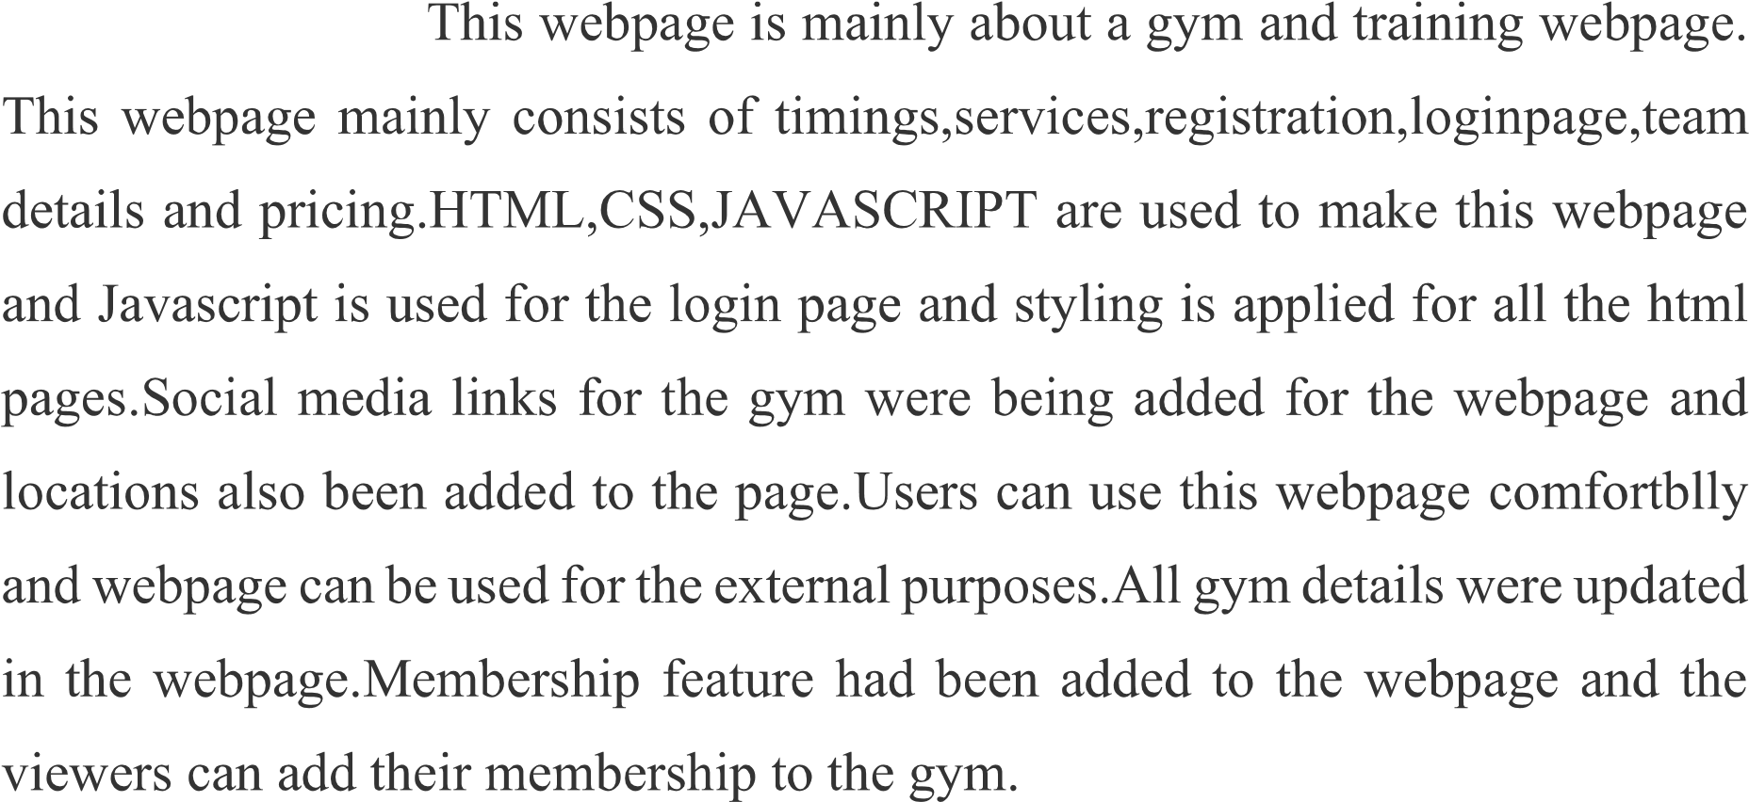

|  |  |  |
| --- | --- | --- |
|  |  |  |
|  |  |  |
|  |  |  |
|  |  |  |
|  |  |  |
|  |  |  |
|  |  |  |
|  |  |  |
|  |  |  |
|  |  |  |
|  |  |  |
|  |  |  |
|  |  |  |
|  |  |  |

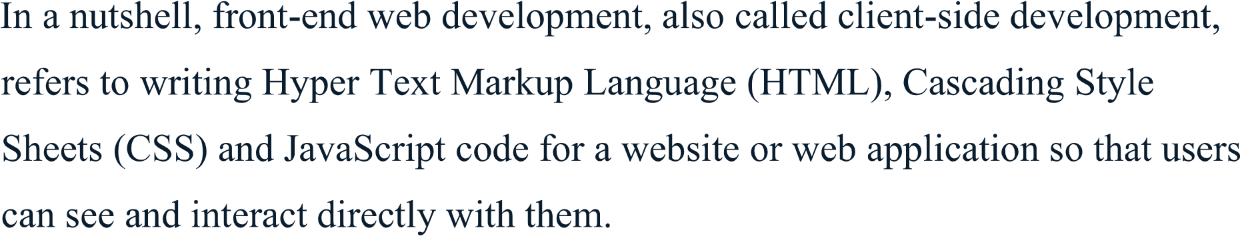

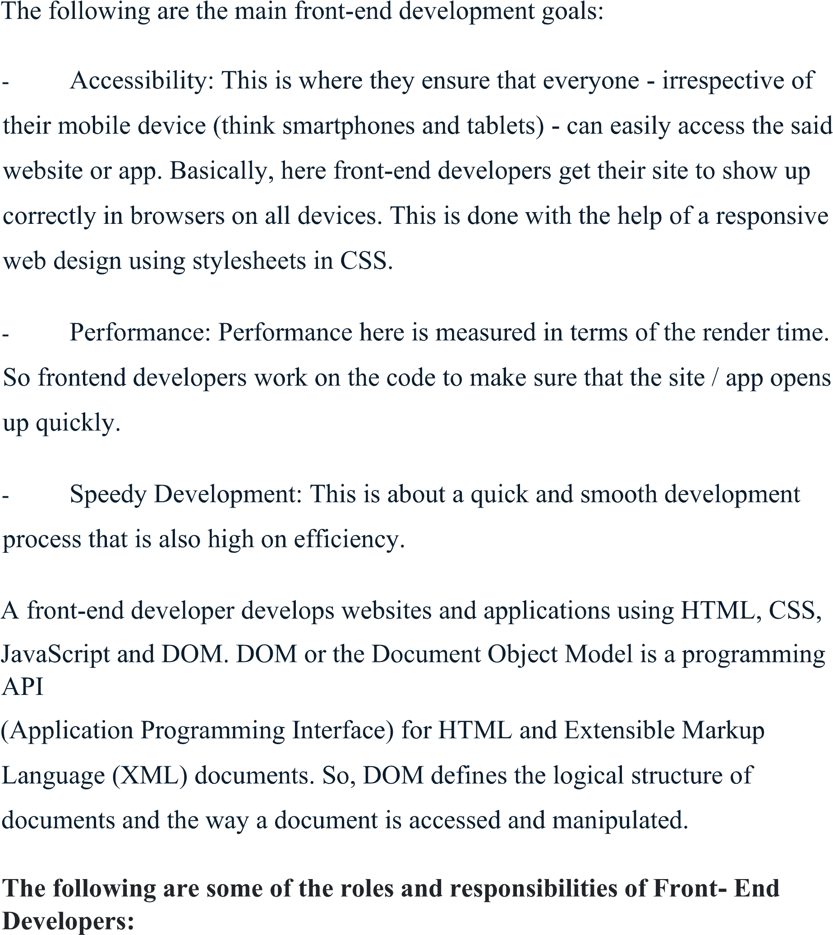

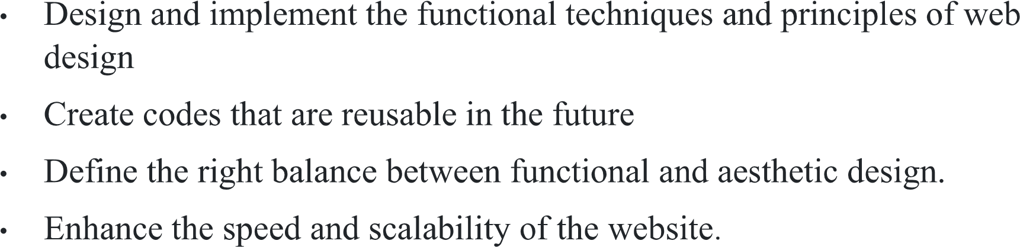

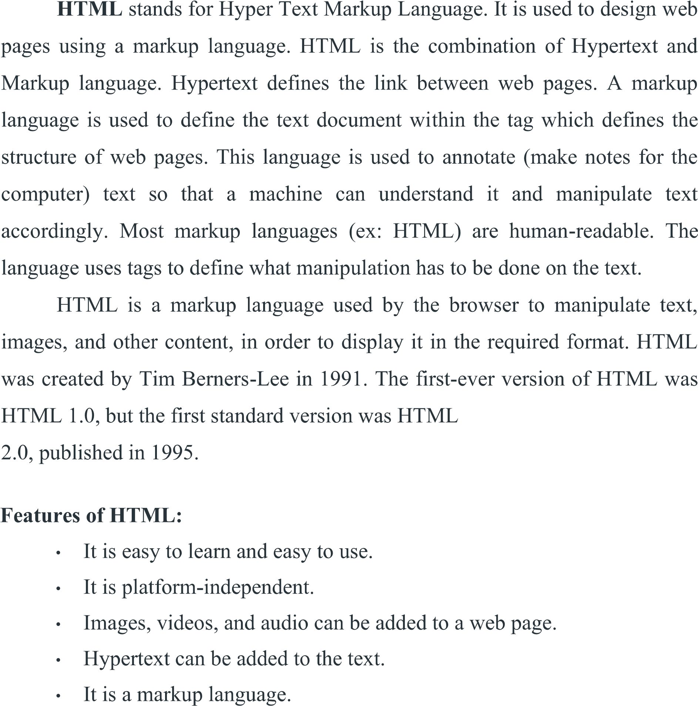



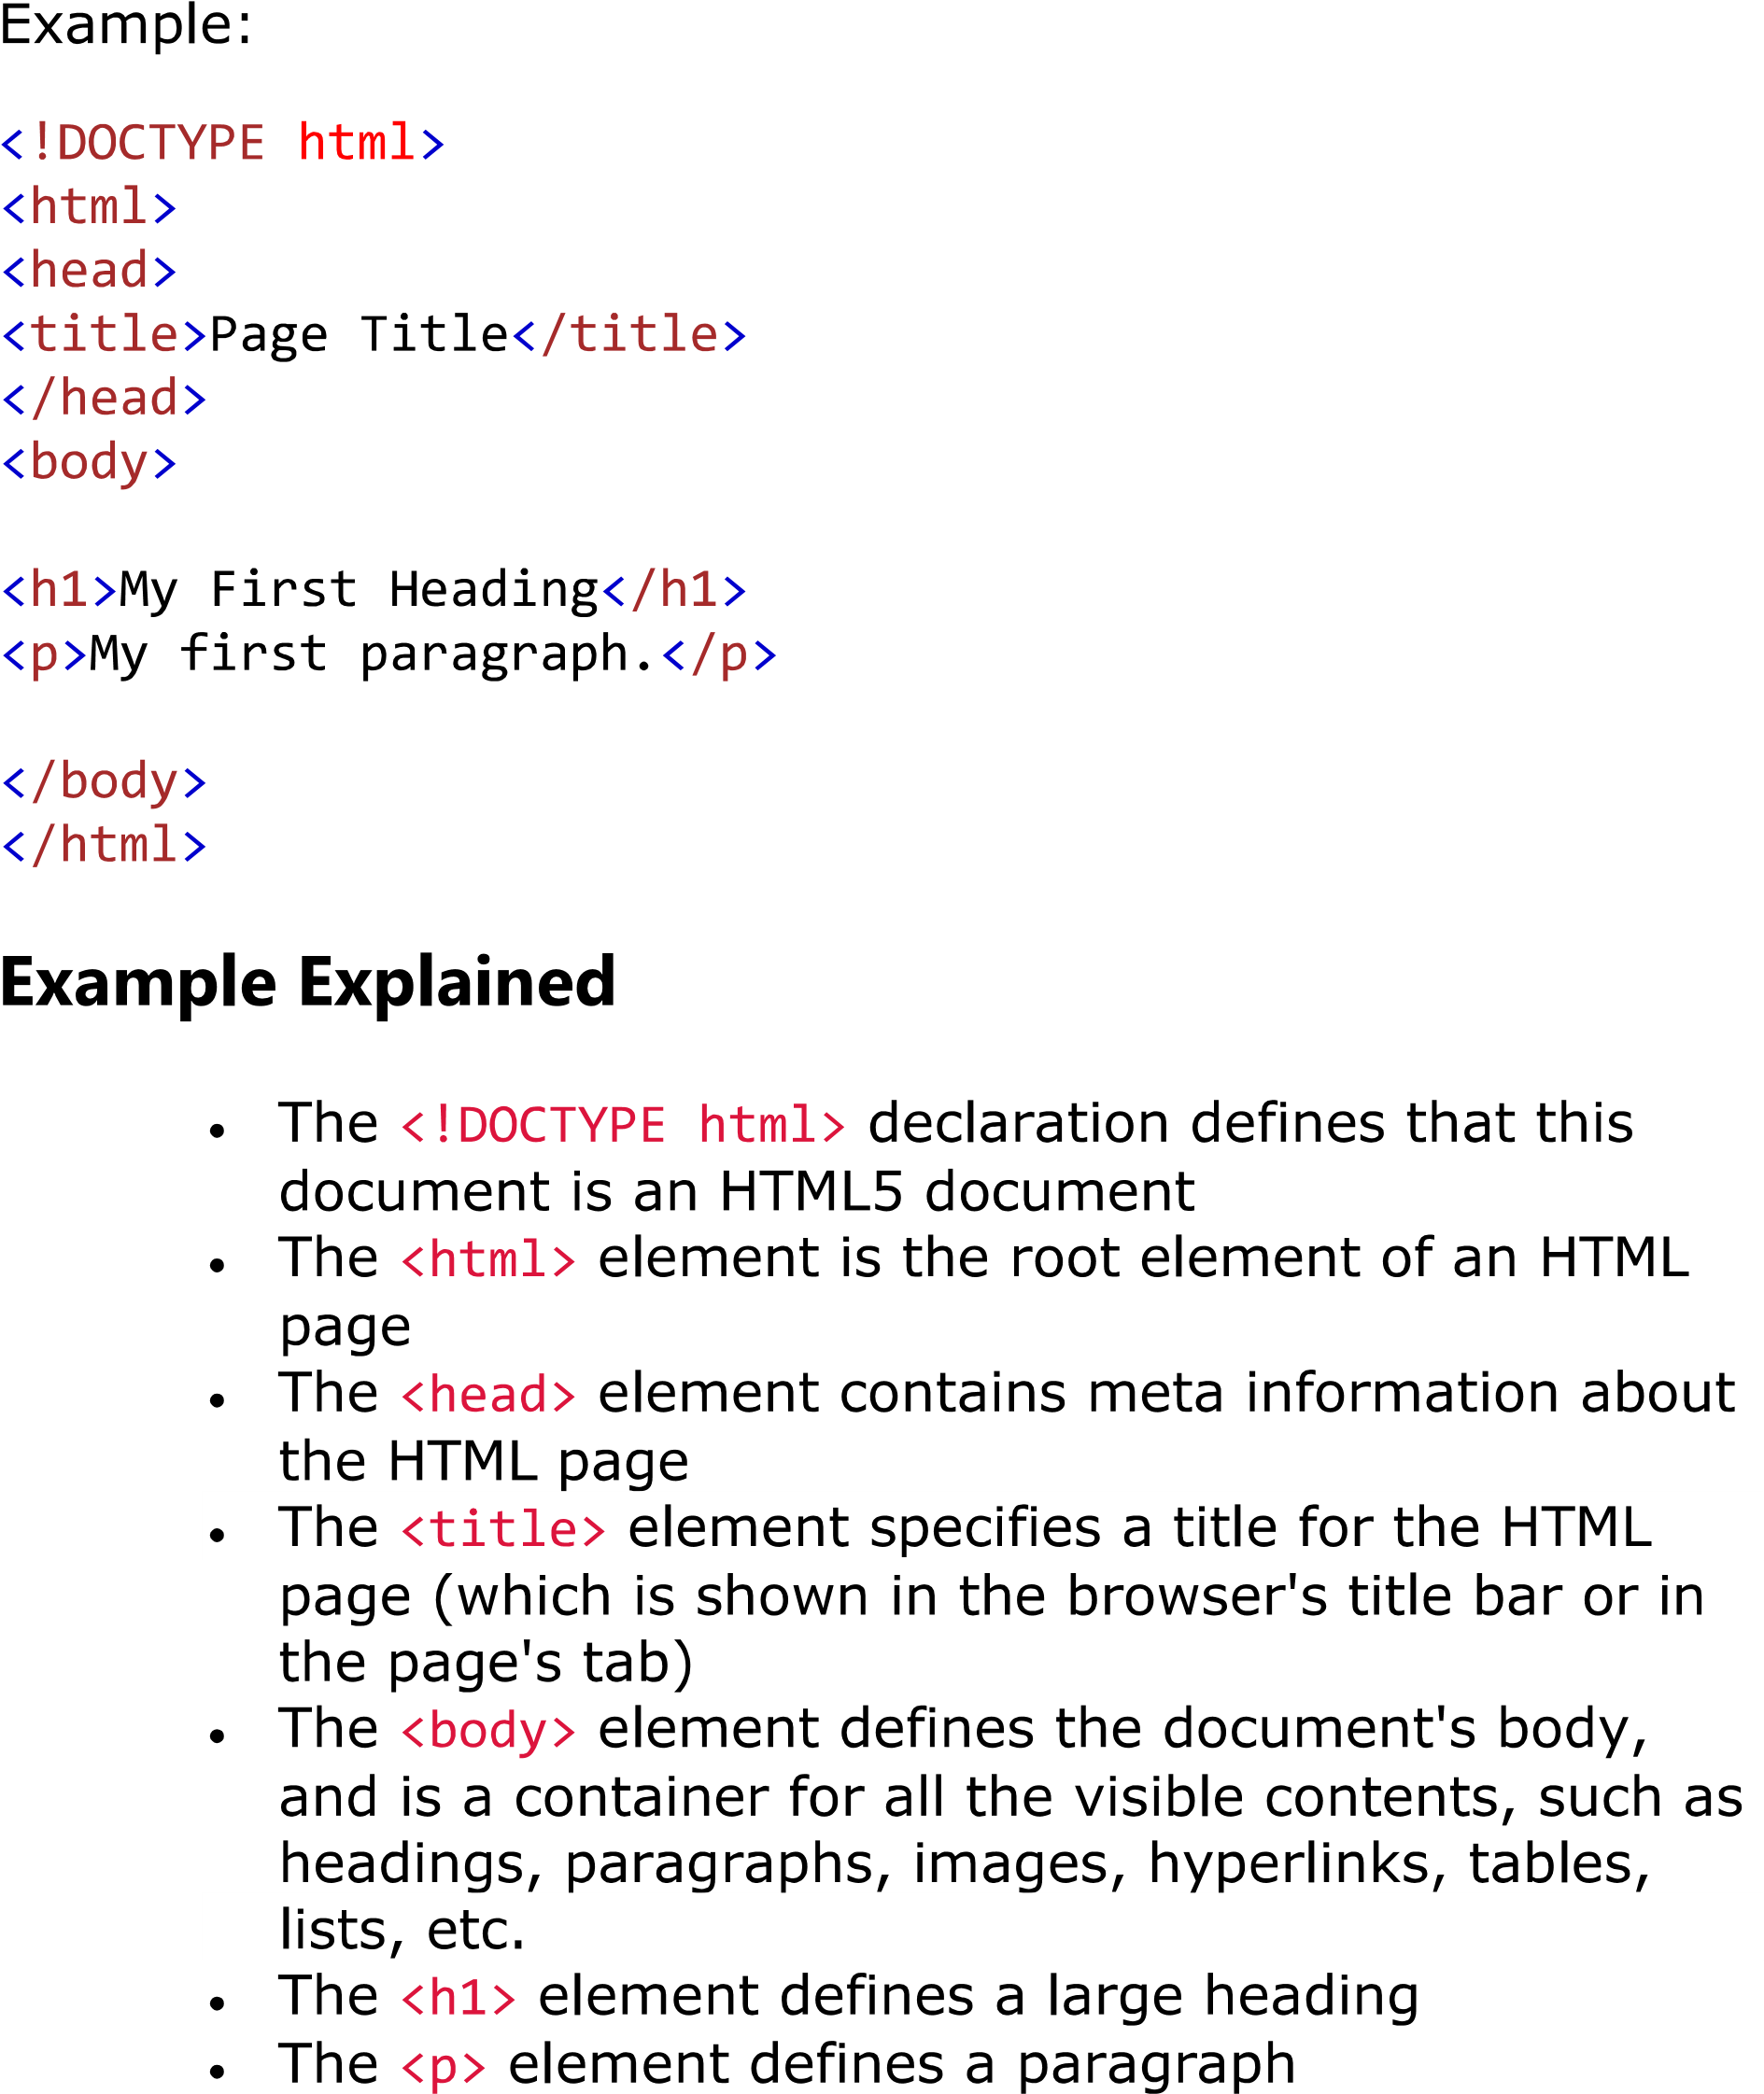

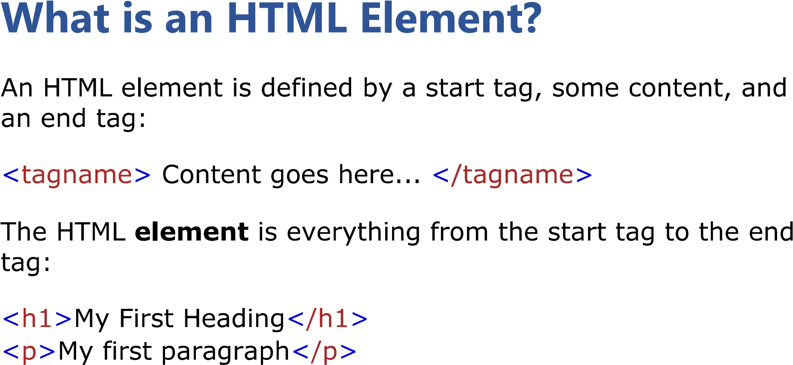

|  |  |  |
| --- | --- | --- |
|  |  |  |
|  |  |  |
|  |  |  |
|  |  |  |

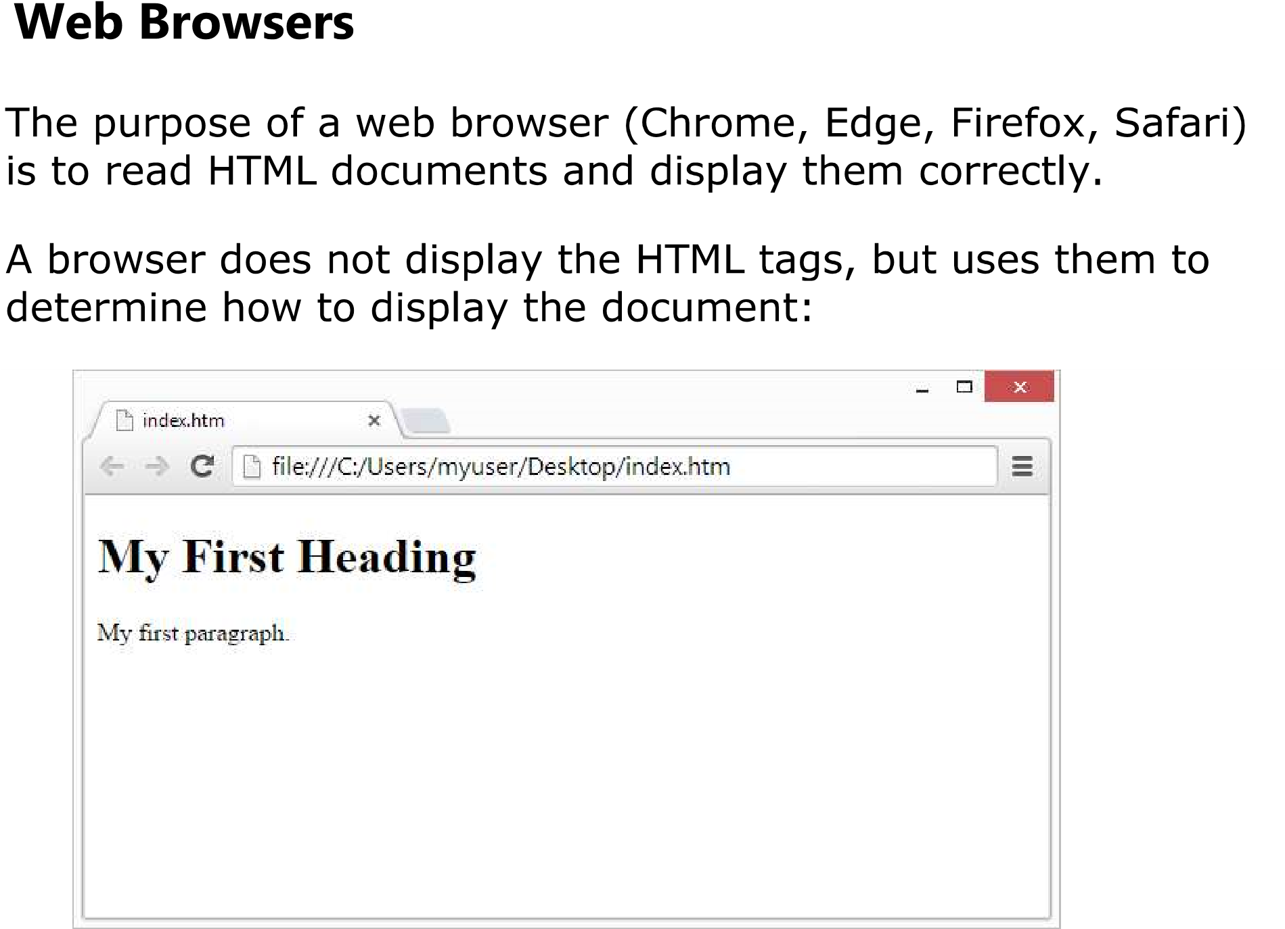

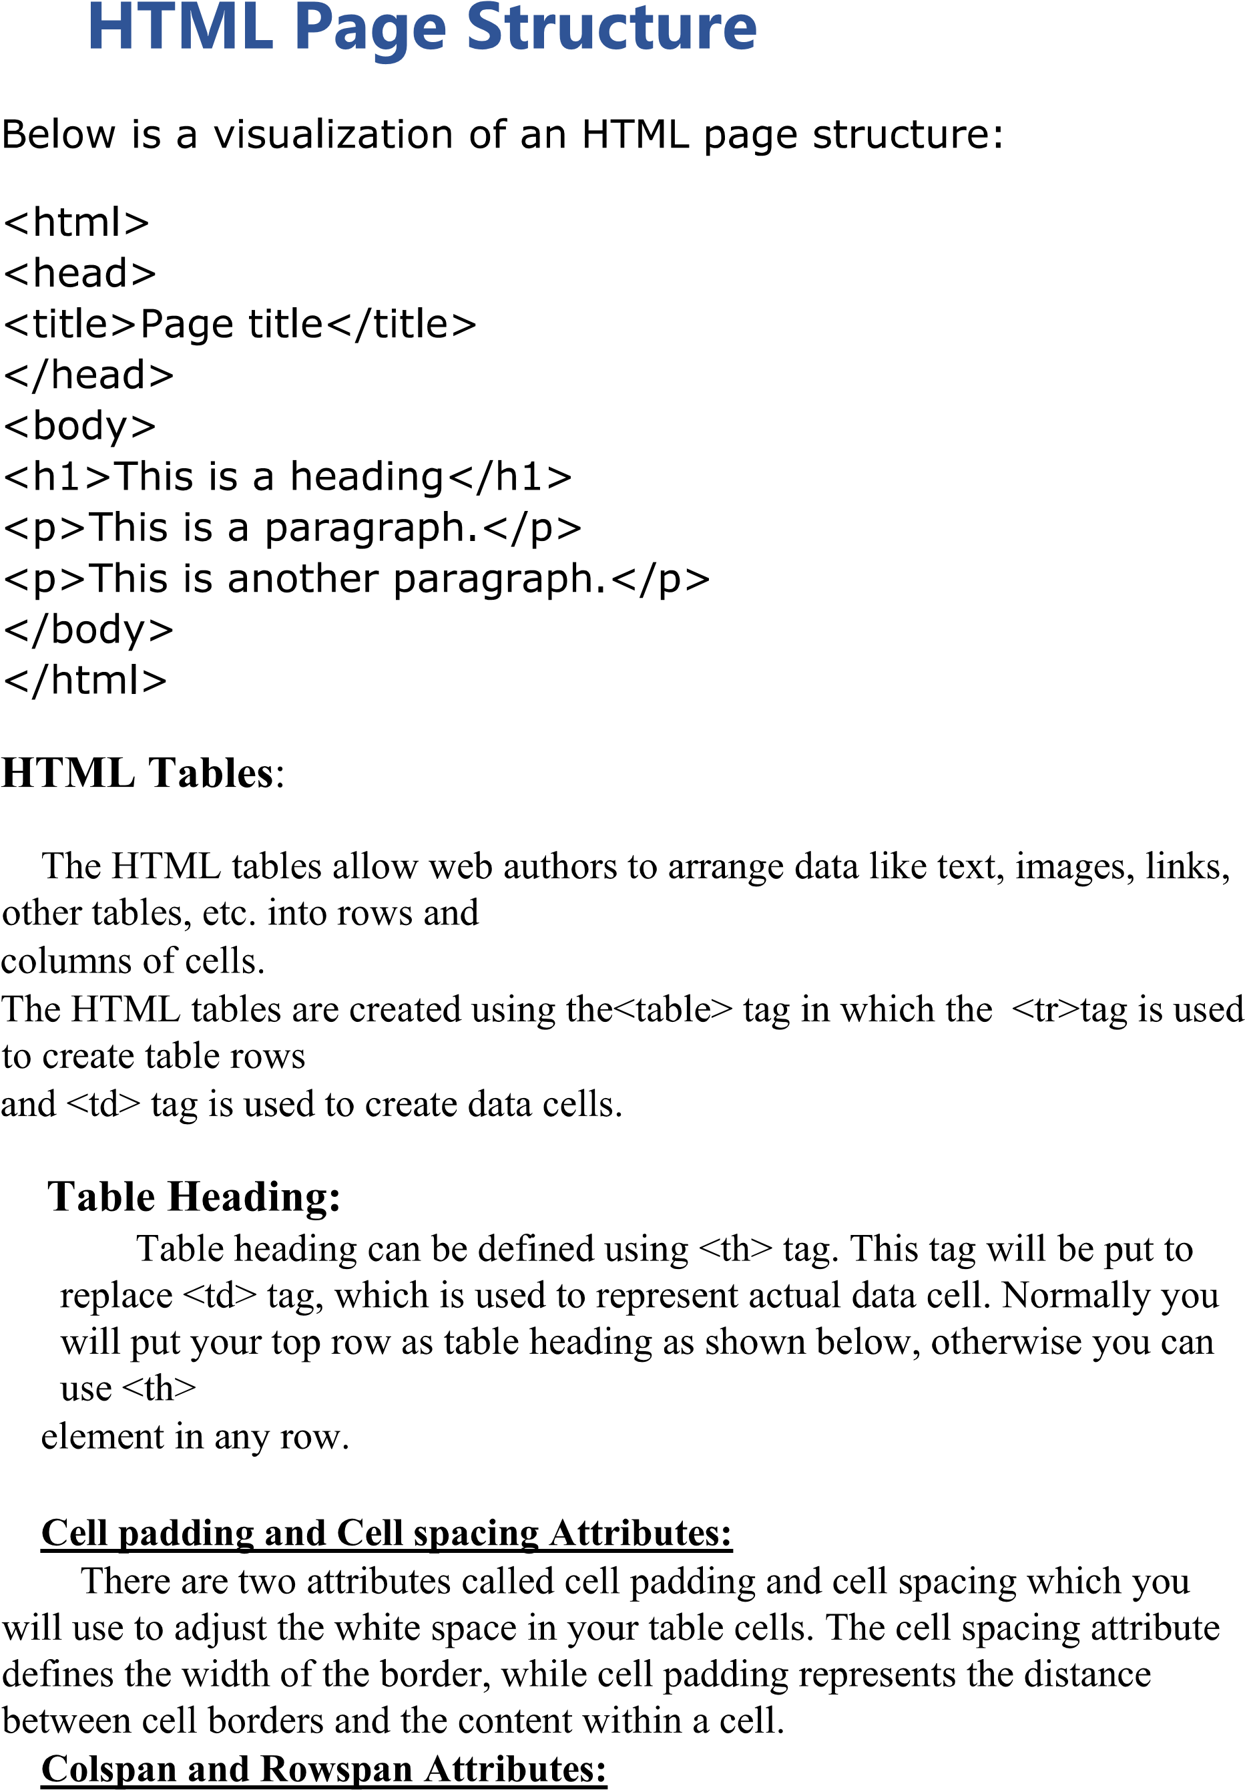

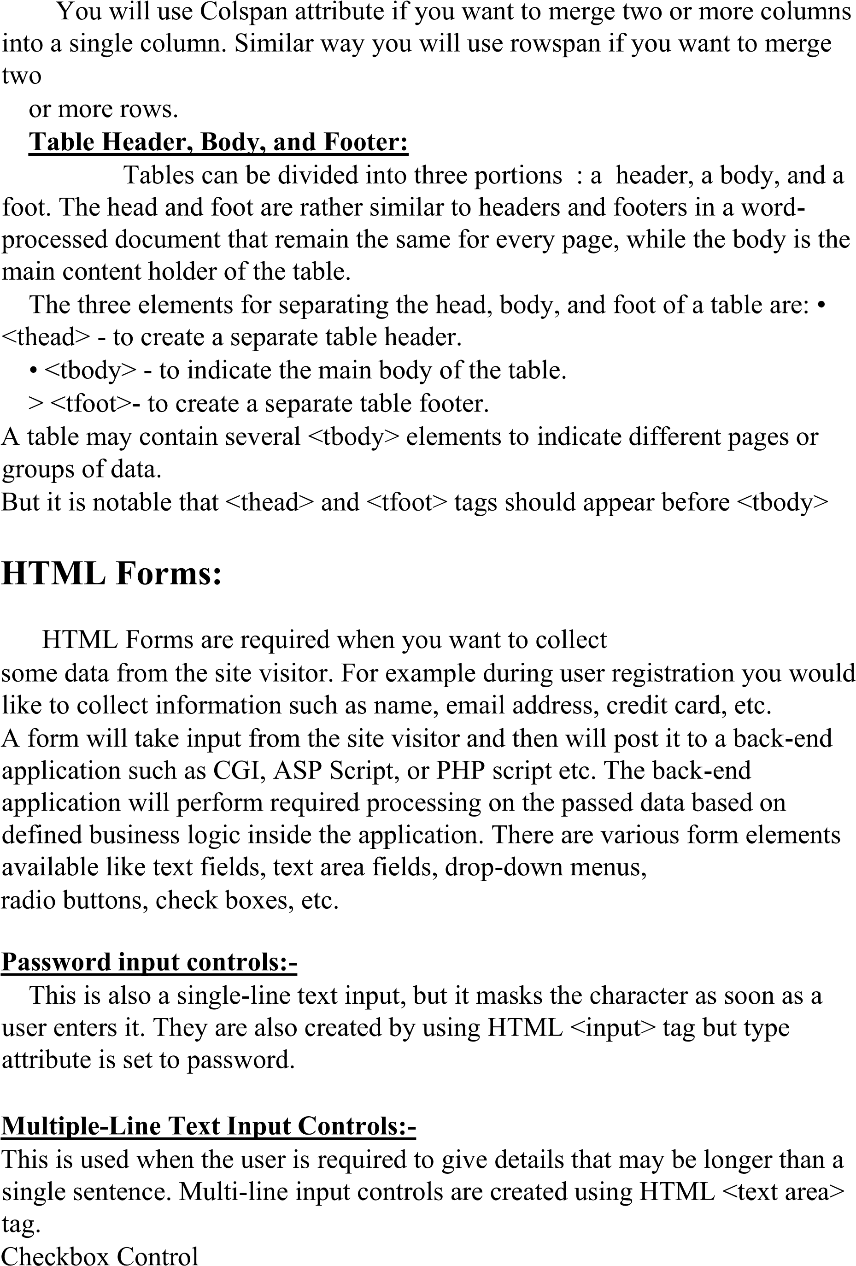

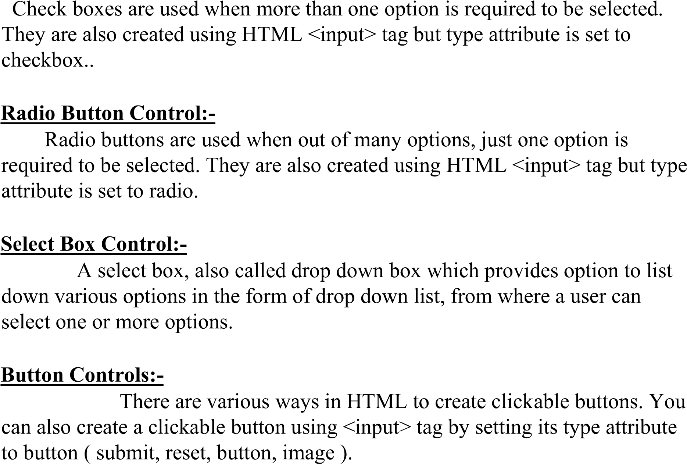

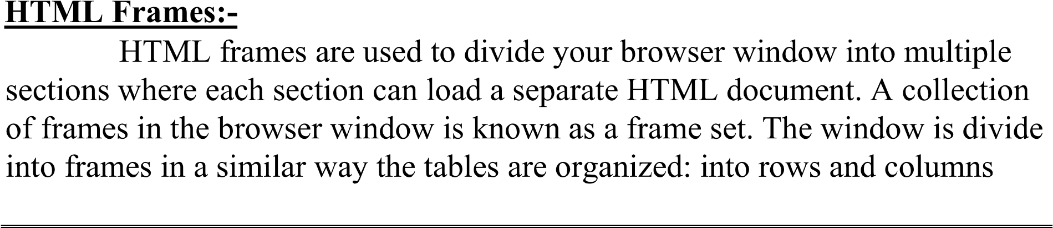

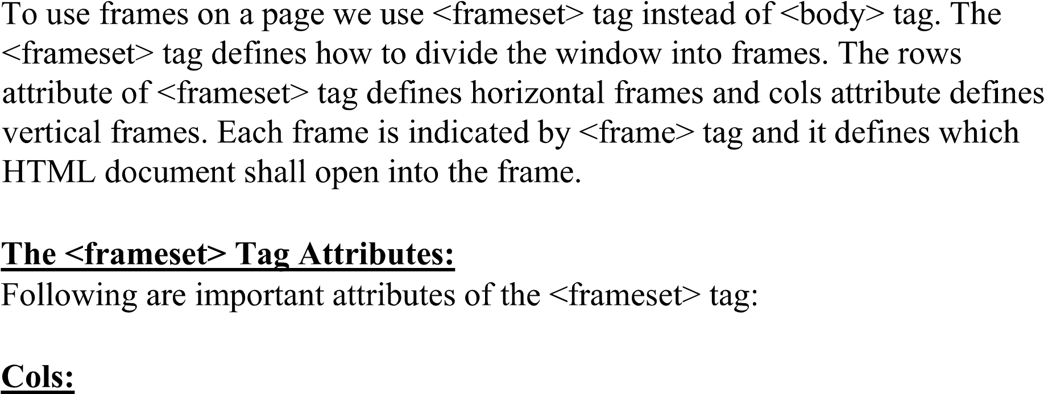



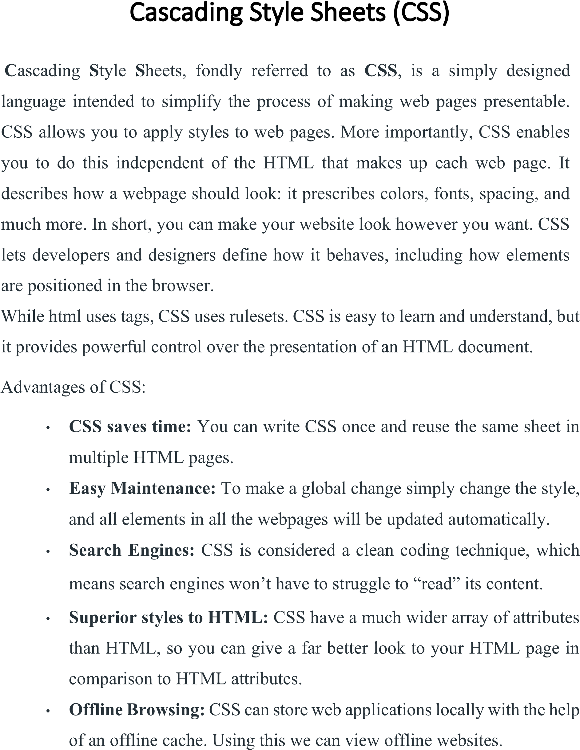

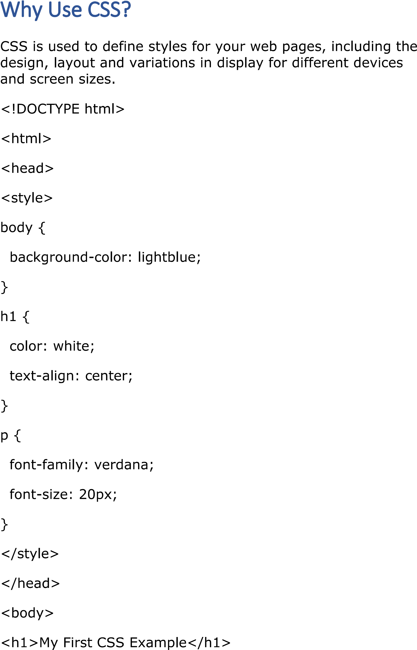

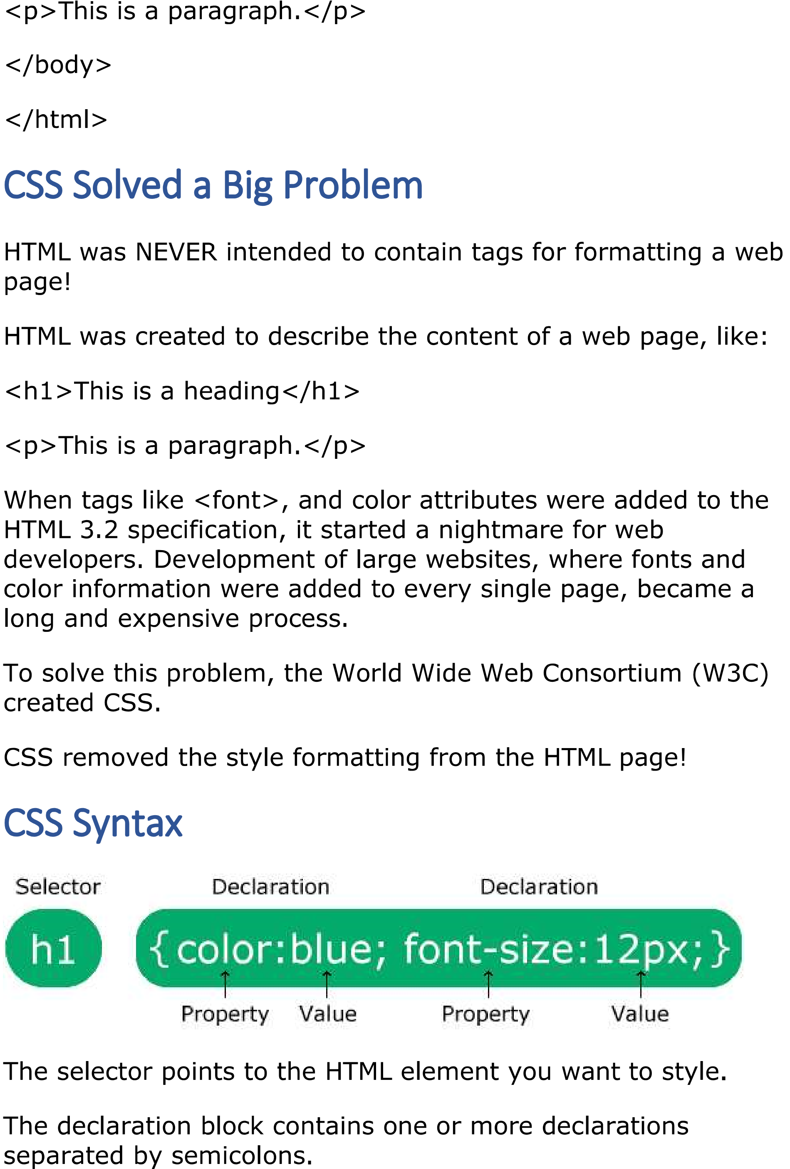





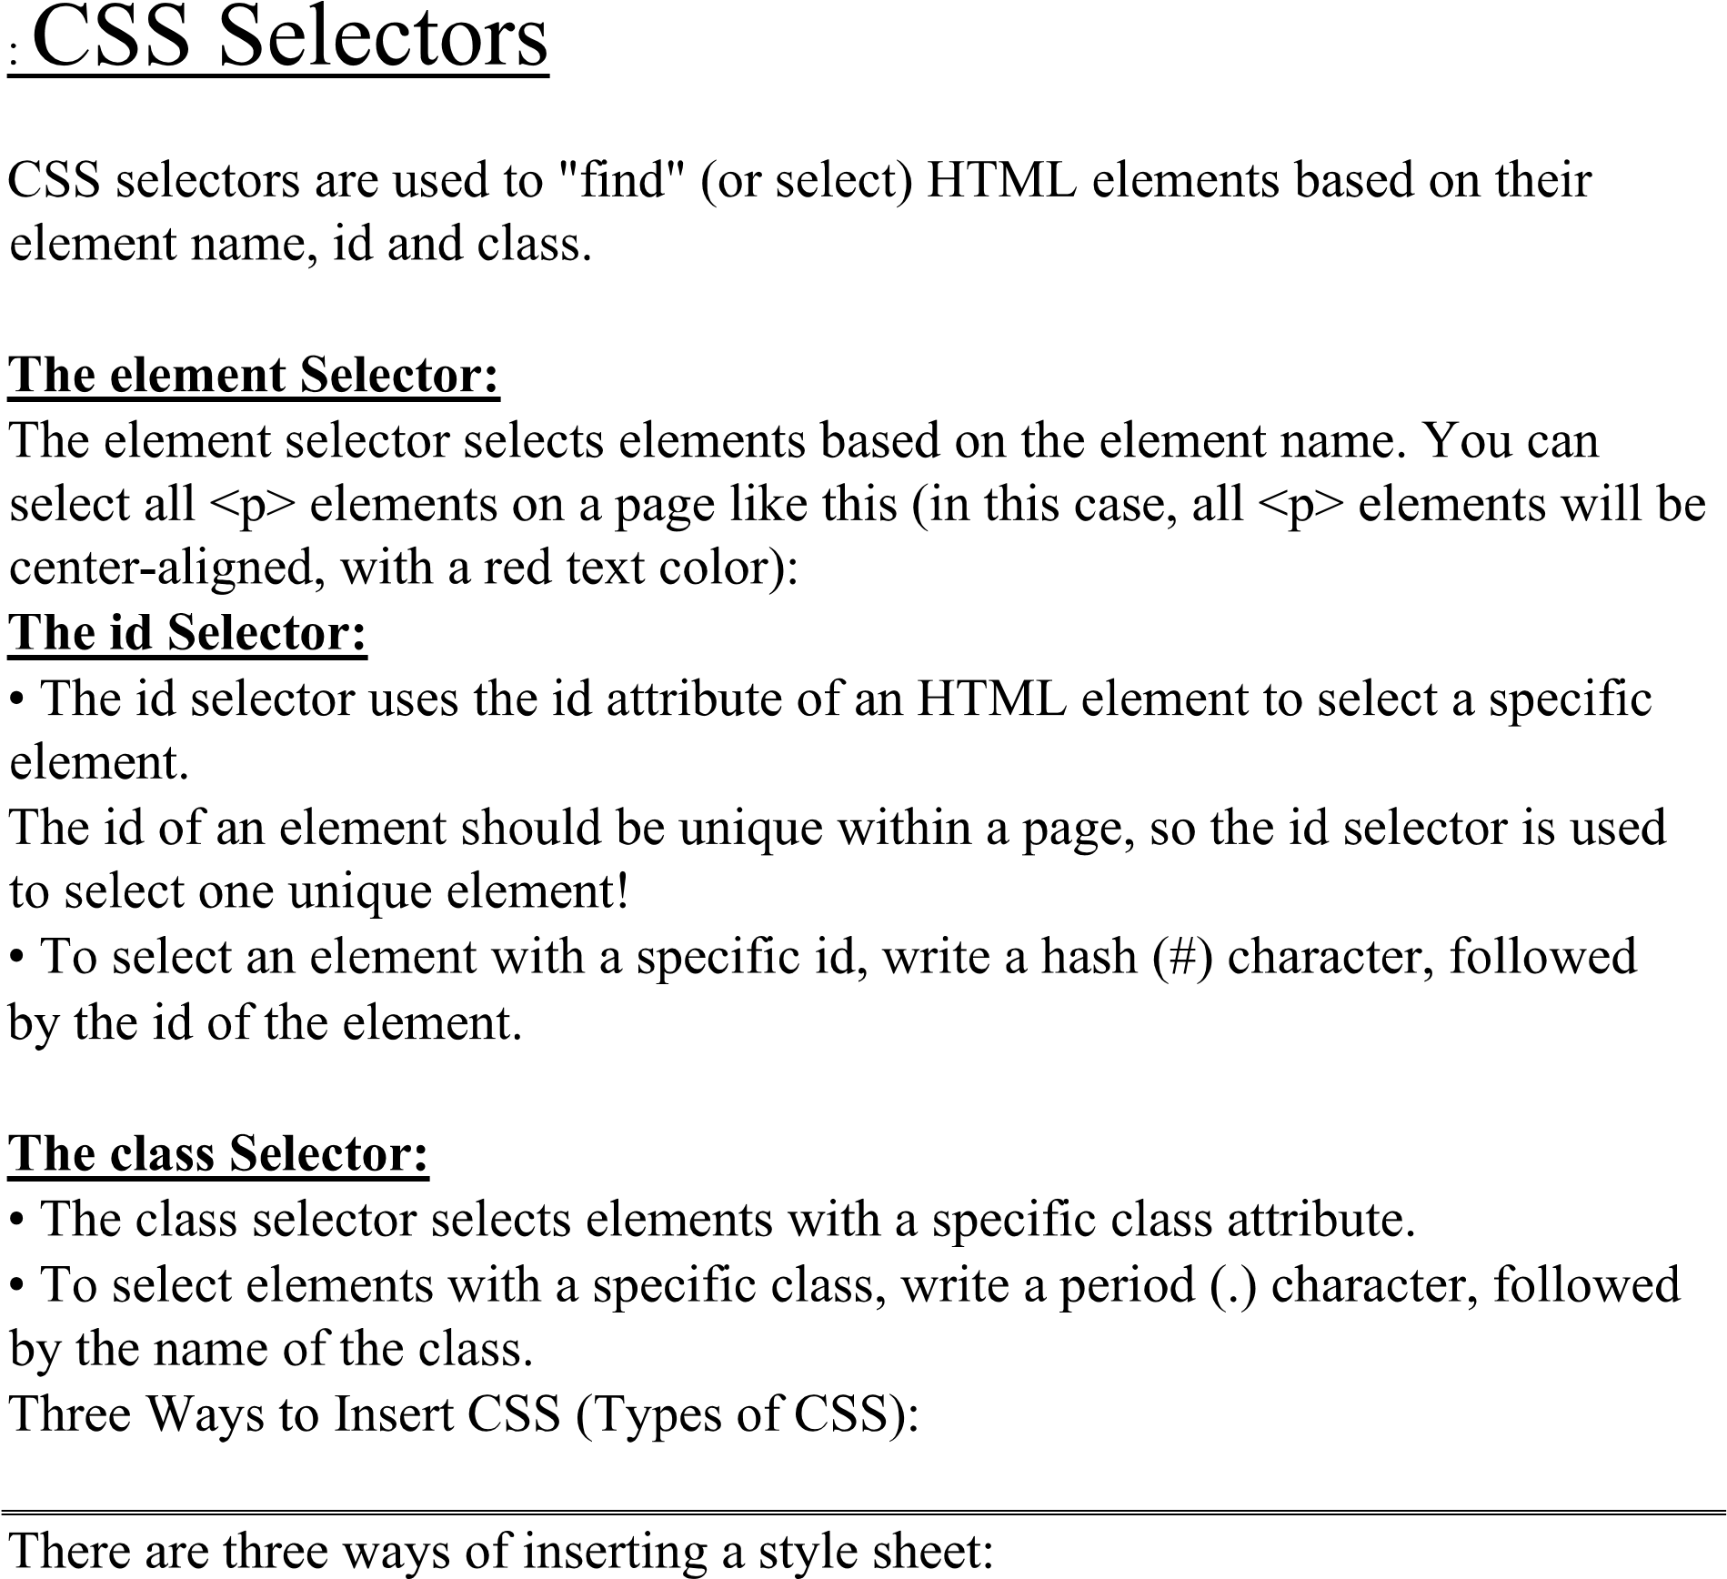

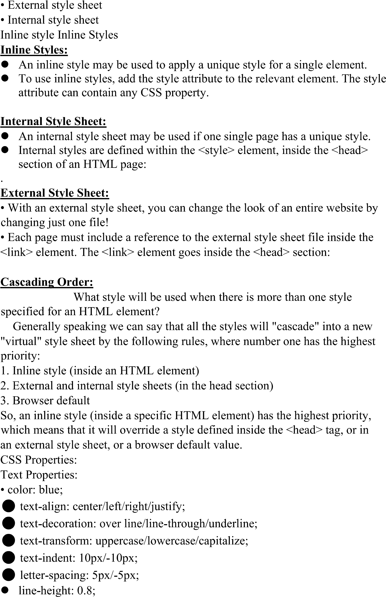

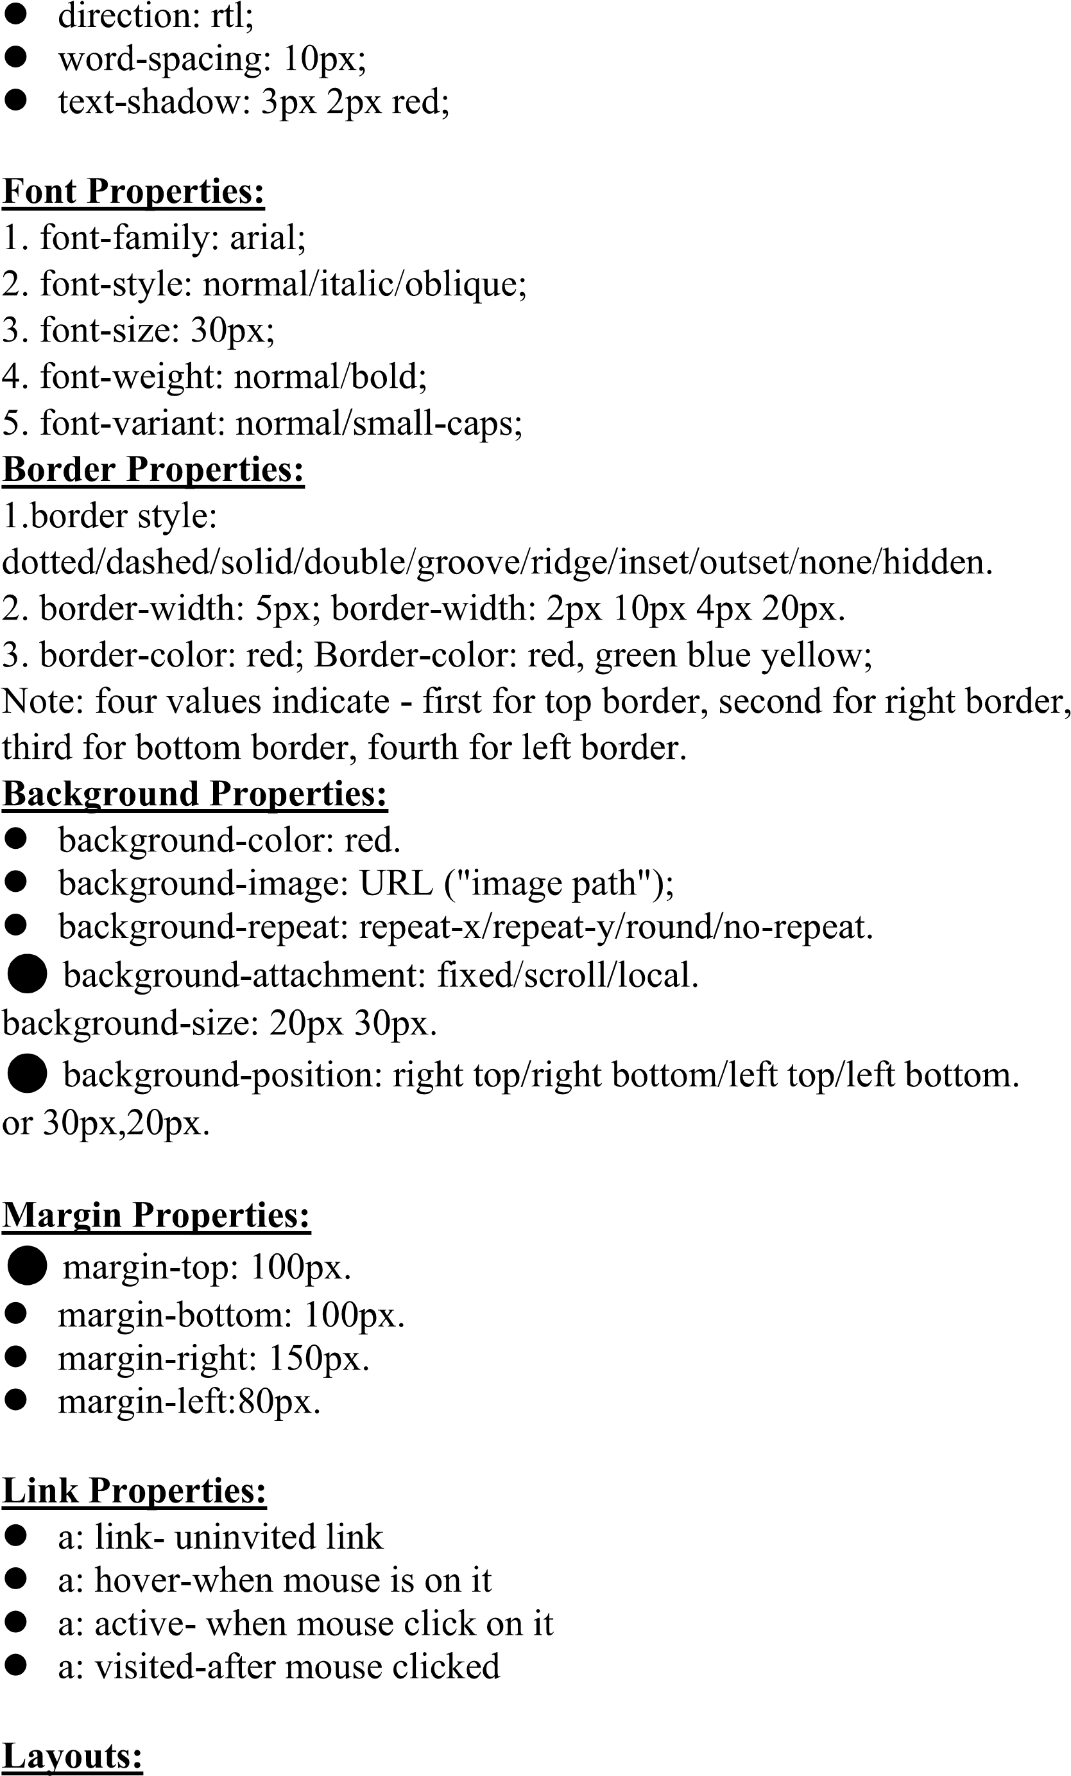

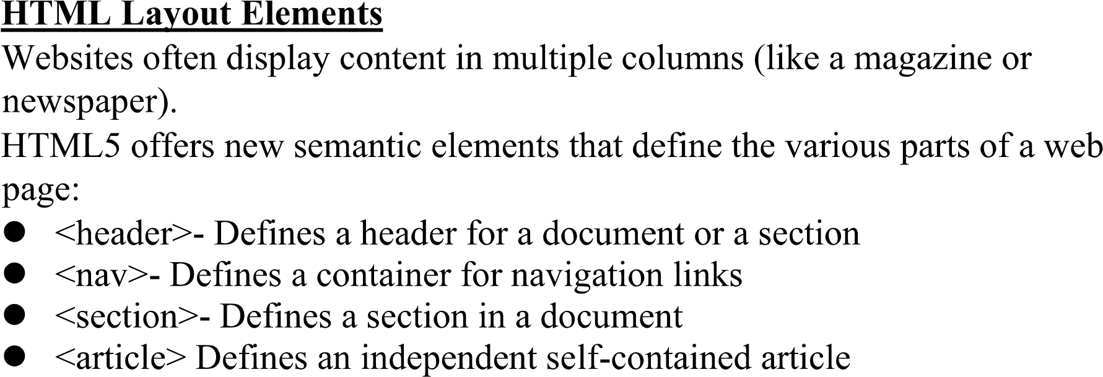

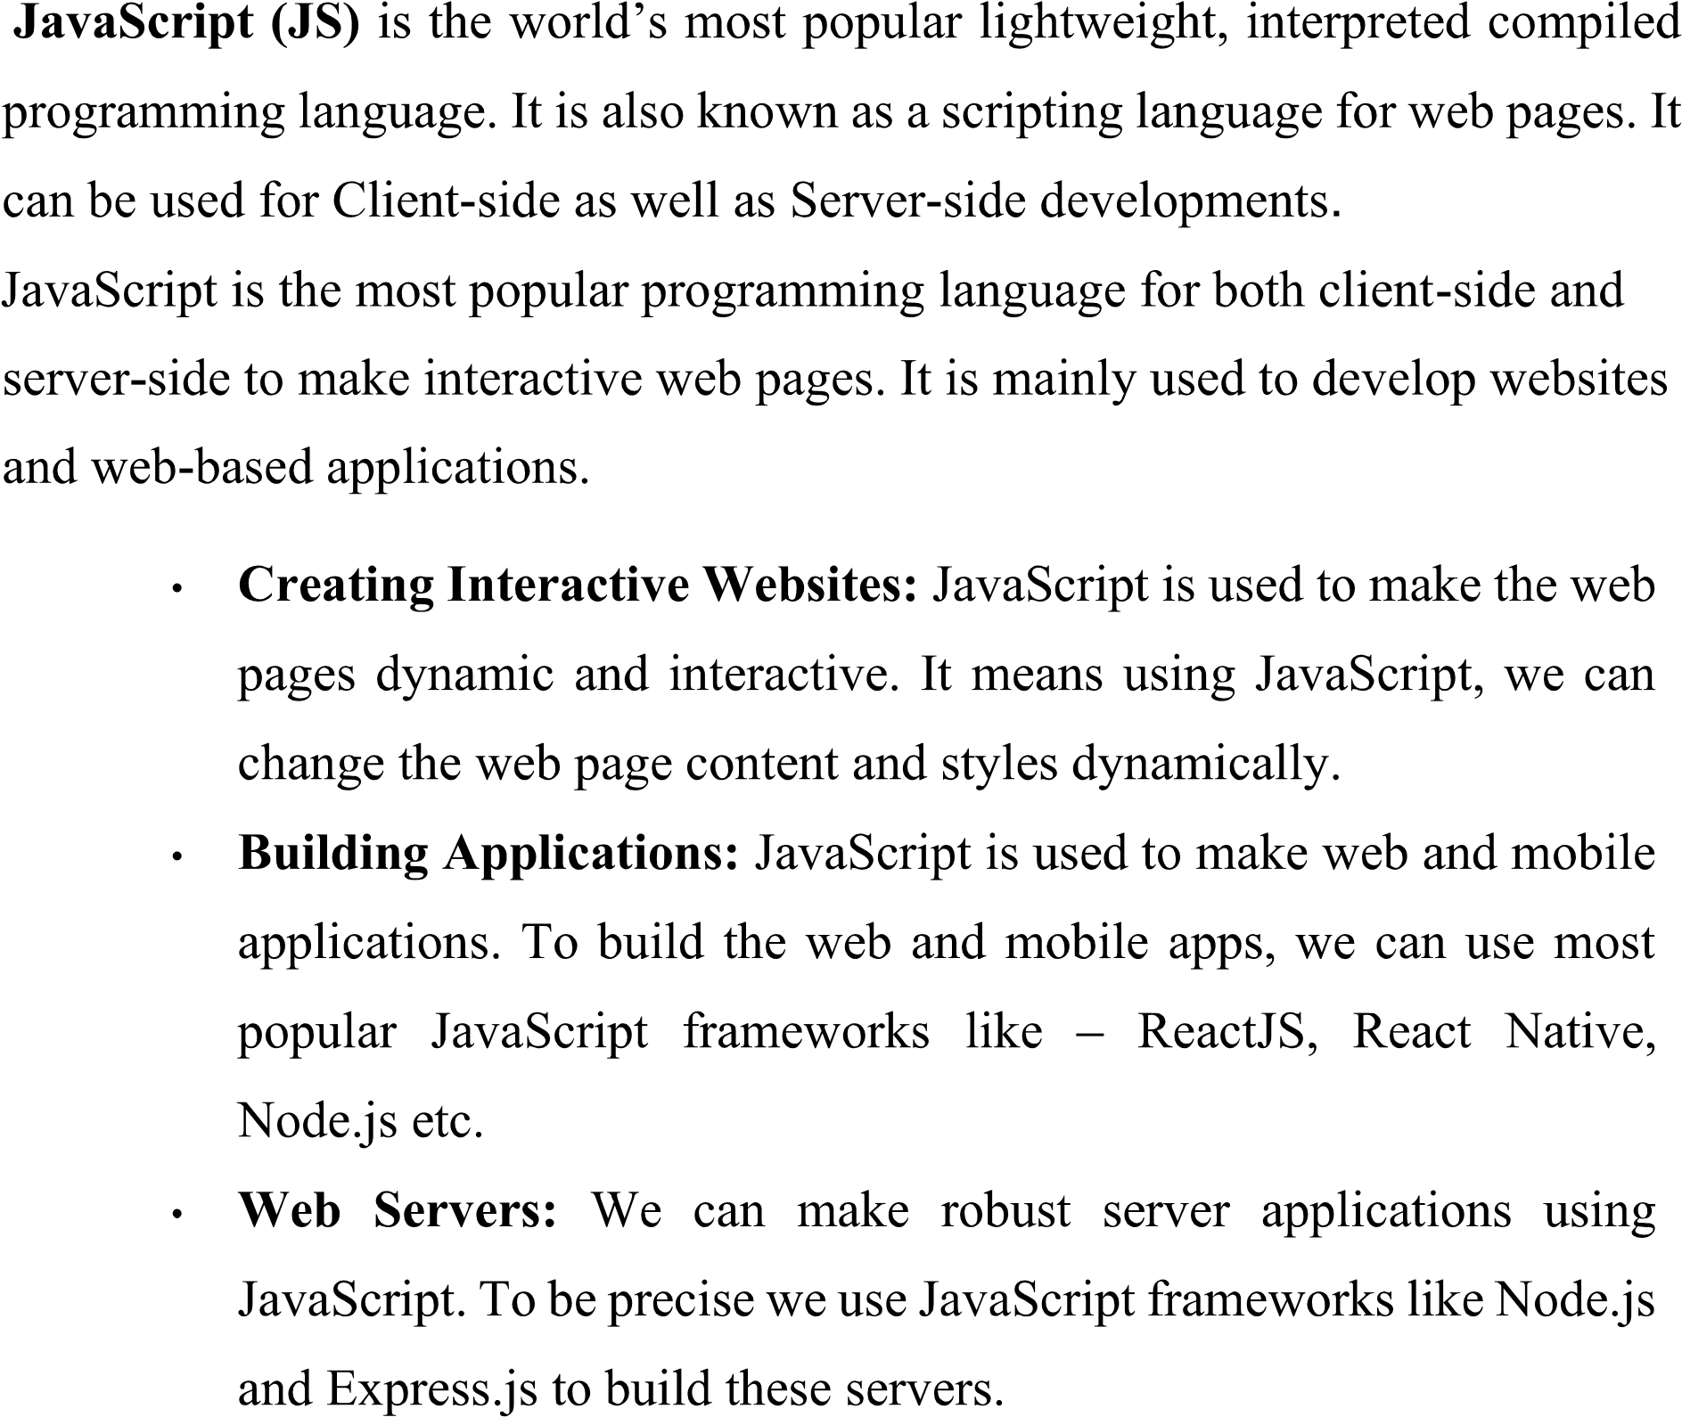



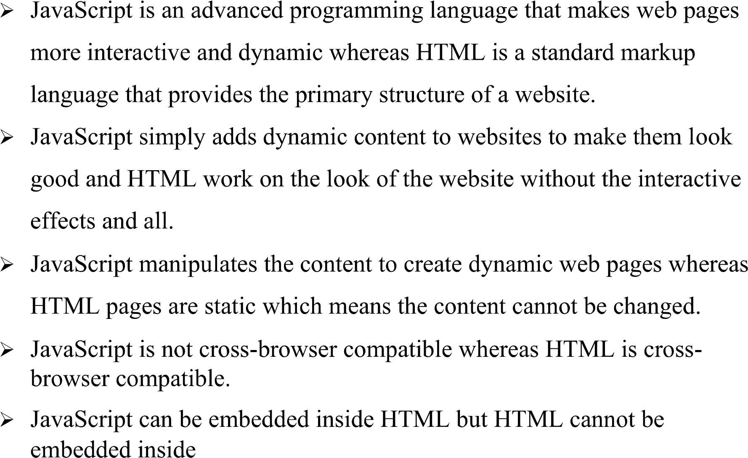





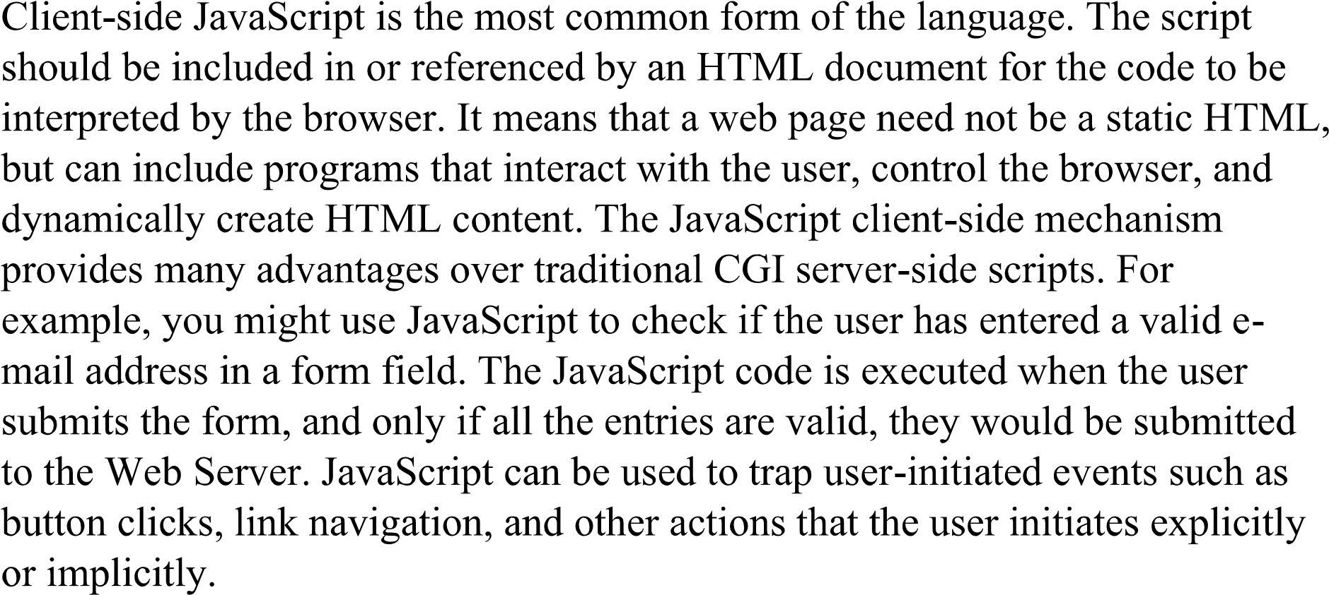













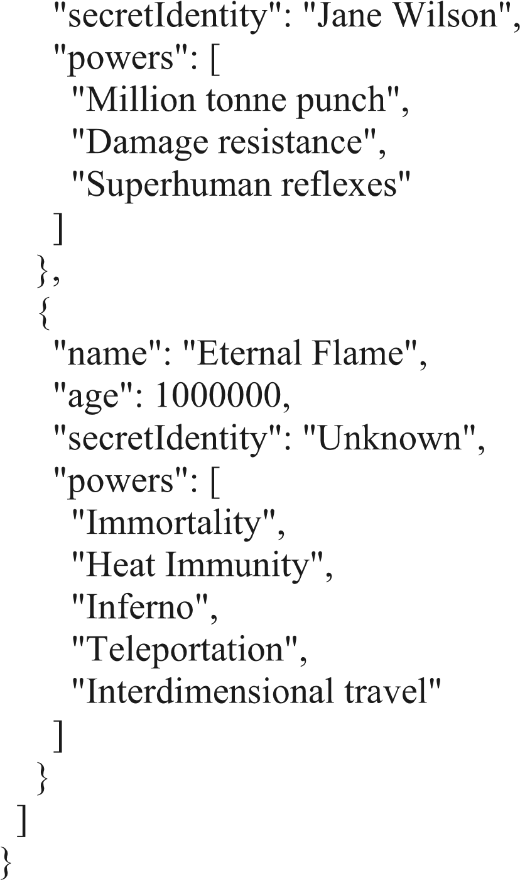





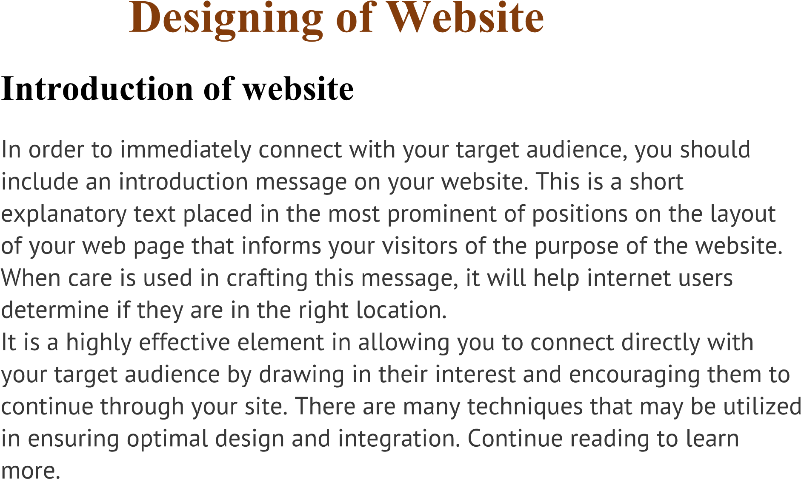



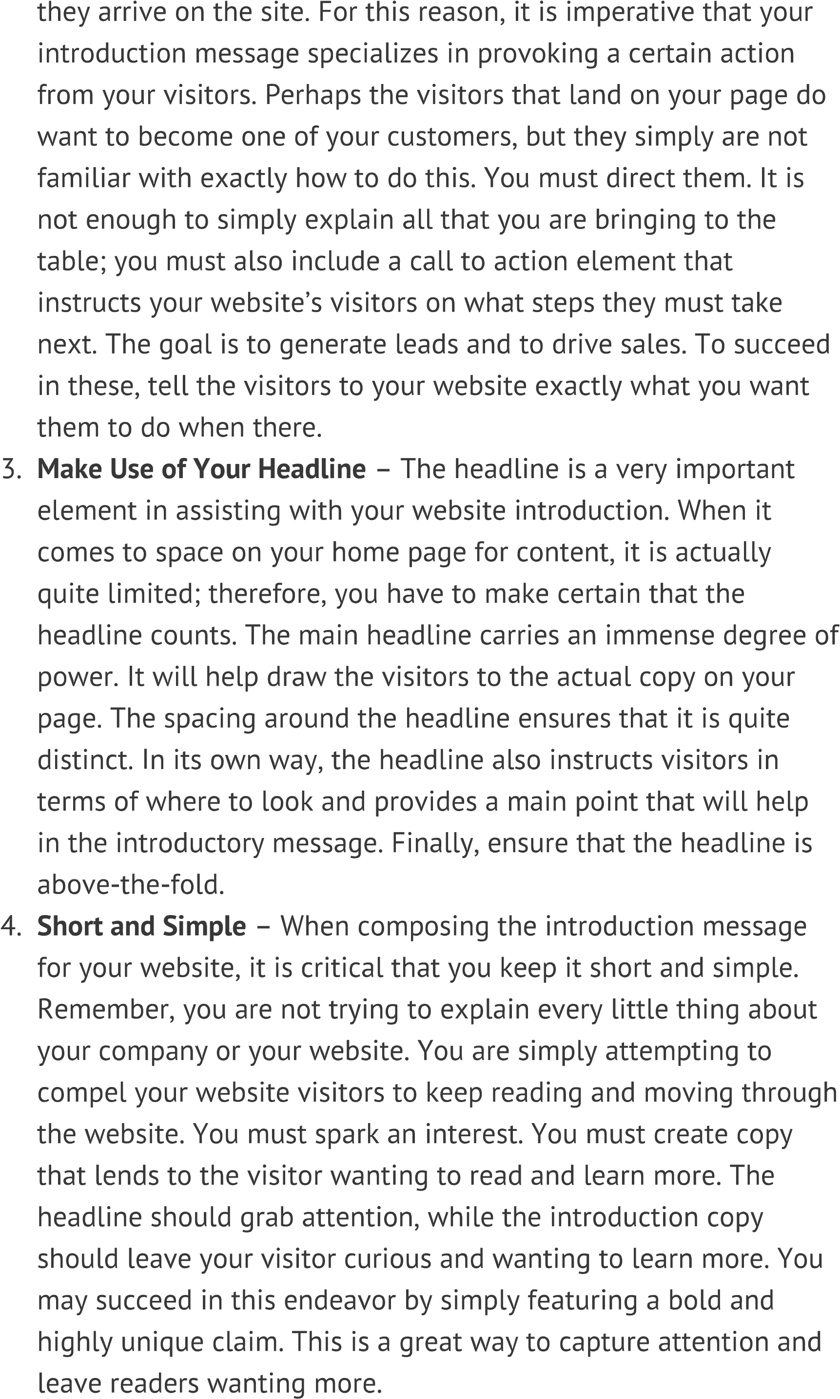

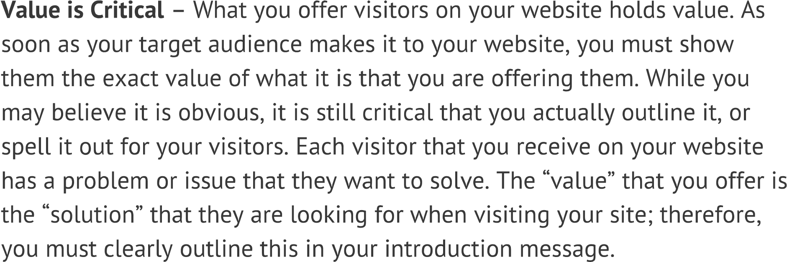

<html>

<head>

    <title>HOSPITAL WEBSITE</title>

</head>

<!-- google font links -->

<link rel="preconnect" href="https://fonts.googleapis.com">

<link rel="preconnect" href="https://fonts.gstatic.com" crossorigin>

<link href="https://fonts.googleapis.com/css2?family=Sevillana&display=swap" rel="stylesheet">

<link rel="stylesheet" href="https://cdnjs.cloudflare.com/ajax/libs/font-awesome/6.2.1/css/all.min.css">

<!-- own css filelink -->

<link rel="stylesheet" href="hospitalweb.css">

<link rel="stylesheet"

    href="https://fonts.googleapis.com/css2?family=Material+Symbols+Outlined:opsz,wght,FILL,GRAD@48,400,0,0" />

<link rel="stylesheet"

    href="https://fonts.googleapis.com/css2?family=Material+Symbols+Outlined:opsz,wght,FILL,GRAD@20..48,100..700,0..1,-50..200" />

<body onload="scaredloader()">

    <!-- loader starts  -->

    <div id="loading">

        <h2>loading ....</h2>

    </div>

    <!-- header class starts -->

    <header class="header">

        <a href="#" class="logo">

            <script src="https://cdn.lordicon.com/fudrjiwc.js"></script>

            <lord-icon src="https://cdn.lordicon.com/uiaaaqiz.json" trigger="loop"

                colors="primary:#92140c,secondary:#66ee78" style="width:70px;height:70px">

            </lord-icon>

            </div>

            <!-- <span class="material-symbols-outlined">

                    health_and_safety

                    </span> -->

            ganesh hospital

        </a>

        <nav class="navbar">

            <a href="#">home</a>

            <a href="#service1">service</a>

            <a href="#profdoctors1">about</a>

            <a href="#">contact</a>

            <a href="review.html">review</a>

            <a href="booking.html">book</a>

        </nav>

        <div class="menubtn">

            <span class="material-symbols-outlined">

                menu

            </span>

        </div>

    </header>

    <!-- header section ends -->

    <section class="home" id="home1">

      <div class="image">

            <img src="codeimages/Hospital family visit-pana.svg">

        </div>

    </section>

    <!-- header section ends  -->

    <!-- special section starts  -->

    <section class="special">

        <!-- <div class="specialhead">

              <h2f >our specials</h2>

        </div> -->

        <div class="specialicons">

            <i class="fas fa-user-md"></i>

            <h3>10+</h3>

            <p>specialists available</p>

        </div>

        <div class="specialicons">

        <i class="fas fa-users"></i>

            <h3>100+</h3>

            <p>sugar patients</p>

        </div>

        <div class="specialicons">

            <i class="fas fa-procedures"></i>

            <h3>1000+</h3>

            <p>beds available</p>

        </div>

        <div class="specialicons">

            <i class="fas fa-hospital"></i>

            <h3>100+</h3>

            <p>hospitals</p>

        </div>

    </section>

    <!-- <div class="specialicons">

        <script src="https://cdn.lordicon.com/fudrjiwc.js"></script>

        <lord-icon

            src="https://cdn.lordicon.com/nrgmvdiu.json"

            trigger="hover"

            colors="outline:#121331,primary:#f7c7be,secondary:#e9e4ed"

            style="width:100px;height:100px">

        </lord-icon>

    </div> -->

    <!--< special section ends  -->

    <!-- service section starts  -->

    <section class="service" id="service1">

        <h1 class="serviceheading">our <span>services</span></h1>

        <div class="serviceboxcontainer">

            <div class="servicebox">

                <i class="fas fa-notes-medical"></i>

                <h3>medical</h3>

                <p>data must written</p>

            </div>

            <div class="servicebox">

                <i class="fas fa-pills"></i>

                <h3>medicines</h3>

                <p>data must written</p>

            </div>

            <div class="servicebox">

                <i class="fas fa-user-md"></i>

                <h3>user</h3>

                <p>data must written</p>

            </div>

            <div class="servicebox">

                <i class="fas fa-ambulance"></i>

                <h3>ambulance</h3>

                <p>data must written</p>

            </div>

            <div class="servicebox">

                <i class="fas fa-heartbeat"></i>

                <h3>heartbeat</h3>

                <p>data must written</p>

            </div>

        </div>

    </section>

    <!-- service section ends  -->

    <section class="profdoctors" id="profdoctors1">

        <h1 class="profdoctorsheading">professional doctors</h1>

        <div class="profdoctorsboxcontainer">

            <div class="profbox">

                <img src="codeimages/dentist.jpg">

                <h3>deepika padukone</h3>

                <span>dentist</span>

                <div class="share">

                    <a href="" class="fab fa-linkedin"></a>

                    <a href="" class="fab fa-facebook"></a>

                    <a href="" class="fab fa-instagram"></a>

                    <a href="" class="fab fa-twitter"></a>

                    <a href="" class="fab fa-youtube"></a>

                </div>

            </div>

            <div class="profbox">

                <img src="codeimages/surgeon.jpg">

                <h3>The Rock</h3>

                <span>surgeon</span>

                <div class="share">

                    <a href="" class="fab fa-linkedin"></a>

                    <a href="" class="fab fa-facebook"></a>

                    <a href="" class="fab fa-instagram"></a>

                    <a href="" class="fab fa-twitter"></a>

                    <a href="" class="fab fa-youtube"></a>

                </div>

            </div>

            <div class="profbox">

                <img src="codeimages/jhonnydoctor1.jpeg">

                <h3>jhonny sins</h3>

                <span>gynecologist</span>

                <div class="share">

                    <a href="" class="fab fa-linkedin"></a>

                    <a href="" class="fab fa-facebook"></a>

                    <a href="" class="fab fa-instagram"></a>

                    <a href="" class="fab fa-twitter"></a>

                    <a href="" class="fab fa-youtube"></a>

                </div>

            </div>

            <div class="profbox">

                <img src="codeimages/dermatologist.jpg">

                <h3>robert downey jr</h3>

                <span>dermatologist</span>

                <div class="share">

                    <a href="" class="fab fa-linkedin"></a>

                    <a href="" class="fab fa-facebook"></a>

                    <a href="" class="fab fa-instagram"></a>

                    <a href="" class="fab fa-twitter"></a>

                    <a href="" class="fab fa-youtube"></a>

                </div>

            </div>

            <div class="profbox">

                <img src="codeimages/neurologist.jpg">

                <h3>jackie chan</h3>

                <span>neurologist</span>

                <div class="share">

                    <a href="" class="fab fa-linkedin"></a>

                    <a href="" class="fab fa-facebook"></a>

                    <a href="" class="fab fa-instagram"></a>

                    <a href="" class="fab fa-twitter"></a>

                    <a href="" class="fab fa-youtube"></a>

                </div>

            </div>

            <div class="profbox">

                <img src="codeimages/cardioligist.jpg">

                <h3>sampoornesh babu</h3>

                <span>cardioligist</span>

                <div class="share">

                    <a href="" class="fab fa-linkedin"></a>

                    <a href="" class="fab fa-facebook"></a>

                    <a href="" class="fab fa-instagram"></a>

                    <a href="" class="fab fa-twitter"></a>

                    <a href="" class="fab fa-youtube"></a>

                    <a href="" class="fab fa-pinterest"></a>

                </div>

            </div>

        </div>

    </section>

    <!-- about section starts  -->

    <section class="about" id="about1">

        <h1 class="aboutheading">About us</h1>

        <div class="doctors">

            <div class="aboutimg">

                <img src="codeimages/ganeshdoctor.jpg" height="360px" width="270px">

            </div>

            <div class="aboutcontent">

                <h3 id="aboutspecial">About Specialist Doctor</h3>

                <p>GANESH JAGGINENI is known as the best doctor in the world and also one of the richest doctors in the

                    world. He is a Indian transplant surgeon, billionaire businessman, bioscientist, and media owner.

                    Not only this, he is also the discoverer of the drug Abraxane, which has become recognized for its

                    effectiveness towards the lung, breast, and pancreatic cancer.

                    He graduated from the GANESH COLLEGE OF PHARMCY at the age of 23, later he studied masters from the

                    University of British Columbia, later he moved to the United States and did his surgical training

                    from there. He started his career as a transplant surgeon in 1991.

                    In 1984 and 1987, he worked in the position of a partner researcher on the Center for Ulcer Research

                    and Education. GANESH JAGGINENI did the primary entire-pancreas transplant accomplished at UCLA, and

                    he evolved and primarily did the experimental Type 1 diabetes-remedy called encapsulated-human-islet

                    transplant, and the "first pig-to-man islet-cell transplant in diabetic patients."After a length in

                    the industry, he returned back to UCLA in 2009, serving as a professor of microbiology, immunology,

                    molecular genetics, and bioengineering until today. GANESH JAGGINENI also worked as a tour professor

                    for sometime in London's Imperial College, during the year 2011.

                    GANESH JAGGINENI made a $12 million donation to the University of Utah in 2014, which sparked media

                    scrutiny and allegations that GANESH JAGGINENI and his associated company were involved in illegal

                    transactions. On May 29, 2019, the United States Internal Revenue Service finished its audit of the

                    donation and discovered no violation. In addition, the State of Utah Office of the Legislative

                    Auditor General audited the nonprofit's donations and in addition discovered no violation. GANESH

                    JAGGINENI introduced the National Immunotherapy Coalition in early 2016 as a means of encouraging

                    rival pharmaceutical companies to work together to test combinations of cancer-fighting drugs.

                    He has additionally met previous vice-chairman and cutting-edge US president Joe Biden to talk about

                    further ambitious tactics to prevent cancer, which includes carrying out genomic sequencing of

                    100,000 patients to create a big database of ability genetic factors.

                    Furthermore, GANESH JAGGINENI is the founding father of NantWorks, a community of healthcare,

                    biotech, and synthetic intelligence startups; an accessory professor of surgical procedure and

                    executive director of the Wireless Health Institute at the University of California, Los Angeles;

                    and a touring professor at Imperial College London and Dartmouth College. Dr. GANESH JAGGINENI has

                    published more than one hundred medical papers and more than 230 patents covering several areas of

                    technology and medicine across the world.</p>

            </div>

        </div>

    </section>>

    <!-- footer section starts  -->

    <section class="footer" id="footer1">

        <div class="footercont">

            <div class="footbox">

                <h3>web links</h3>

                <a href="#home1"><i class="fas fa-chevron-right">home</i></a>

                <a href="#service1"><i class="fas fa-chevron-right">service</i></a>

                <a href="#profdoctors1"><i class="fas fa-chevron-right">about</i></a>

                <a href="#"><i class="fas fa-chevron-right">contact</i></a>

                <a href="review.html"><i class="fas fa-chevron-right">review</i></a>

                <a href="booking.html"> <i class="fas fa-chevron-right">book</i></a>

            </div>

            <div class="footbox">

                <h3>web links</h3>

                <a href="#"><i class="fas fa-chevron-right">Mental health care</i></a>

                <a href="#"><i class="fas fa-chevron-right">Nutritional counseling</i></a>

                <a href="#"><i class="fas fa-chevron-right">Emergency room services</i></a>

                <a href="#"><i class="fas fa-chevron-right">Blood services</i></a>

                <a href=""><i class="fas fa-chevron-right">Laboratory services</i></a>

            </div>

            <div class="footbox">

                <h3>follow me</h3>

                <a href="https://www.linkedin.com/in/ganesh-jaggineni-352b69206/" class="fab fa-linkedin">linkedin</a>

                <a href="https://www.facebook.com/ganesh.jaggineni" class="fab fa-facebook">facebook</a>

                <a href="https://www.instagram.com/ganesh_jaggineni/" class="fab fa-instagram">instagram</a>

                <a href="" class="fab fa-twitter">twiter</a>

                <a href="https://www.youtube.com/@ganeshjaggineni4097" class="fab fa-youtube">youtube</a>

                <a href="" class="fab fa-pinterest">pinterest</a>

            </div>

            <div class="footbox">

                <h3>contact me</h3>

                <a href="tel:7386878066"><i class="fas fa-phone"></i>7386878066</a>

                <a href="tel:7386878066"><i class="fas fa-phone"></i>9009009001</a>

                <a href="mailto:ganeshjagginenihospital@gmail.com?subject=feedback&body=Hai this is ganesh jaggineni who has founder of ganesh jaggineni's hospital.he is well known for his dedication to help the poor.using less fees he faciliates more equipment and from his hospital he cured all impossible cured diseases such as hiv,sugar,asthma etc......Thank you...visit again"><i

                        class="fas fa-envelope"></i>ganeshjaggineni@gmail.com</a>

                <a href="https://goo.gl/maps/RYzBLkBpZCCJB7uFA"><i

                        class="fas fa-map-marker-alt"></i>gajapathinagaram,india</a>

            </div>

            <div class="credit">created by <span>ganesh jaggineni</span> | no rights reserved</div>

        </div>

    </section>

    <div class="map">

        <h2>ganesh jaggineni's hospital map</h2>

        <iframe class="mapframe"

            src="https://www.google.com/maps/embed?pb=!1m18!1m12!1m3!1d3221.5141237384!2d83.3331864994673!3d18.281772747786526!2m3!1f0!2f0!3f0!3m2!1i1024!2i768!4f13.1!3m3!1m2!1s0x3a3beb24f730beb9%3A0x3f8a8723c7aeaa03!2sGANESH%20JAGGINENI%20HOUSE!5e1!3m2!1sen!2sin!4v1673172247856!5m2!1sen!2sin"

            width="600" height="450" style="border:0;" allowfullscreen="" loading="lazy"

            referrerpolicy="no-referrer-when-downgrade"></iframe>

    </div>

    <script>

        let preloader = document.getElementById("loading");

        function scaredloader() {

            preloader.style.display = 'none';

        }

</script>

</body></html>

Webpage style css

@import url('https://fonts.googleapis.com/css2?family=Pacifico&family=Sevillana&display=swap');

*{

    margin:0;

    padding:0;

    box-sizing:border-box;

    outline:none;

    border:none;

    text-transform: capitalize;

    text-decoration: none;

}

#loading{

    position:fixed;

    width:100%;

    height:100vh;

    background:#fff url("codeimages/scared.gif") no-repeat center;

    z-index:9999;

}

#loading h2{

    position:relative;

    top:50;

    left:50;

    color:rgb(238, 10, 10);

    font-size:50px;

    text-align:center;

}

html{

    font-size:102.5%;

}

.header{

    padding:2rem 9%;

    position:static;

    top:0;

    left:0;

    right:0;

    z-index:1000;

    box-shadow:0 .5rem 1.5rem rgba(0,0,0,0.1);

    display:flex;

    align-items: center;

    justify-content: space-between;

}

.header .logo{

    font-size:2.5rem;

    color:rgb(40, 175, 216);

}

.material-symbols-outlined

{

    color:pink;

}

.header .navbar a{

    font-size:2rem;

    color:green;

    margin-left:1rem;

    font-family:'Sevillana', cursive;

}

.header .navbar a:hover{

color:orange;

background-color:blue;

}

.menubtn{

    font-size:2.5rem;

    border-radius:1rem;

    color:chartreuse;

    padding :0.3rem;

    cursor:pointer;

}

.special{

    display:flex;

    gap:2rem;

    padding-top:2rem;

    padding-bottom:2rem;

    justify-content:space-between;

    border: 2px solid orange;

}

.special .specialicons{

    border:2px solid rgb(0, 87, 128);

    text-align:center;

    padding:2.5rem;

    box-shadow:3px;

}

.special .specialicons i{

    font-size:4.5rem;

    color:rgb(112, 156, 47);

}

.special .specialicons h3{

    font-size:28px;

    color:rgb(206, 39, 117);

    padding:9px;

}

.special .specialicons p{

    font-size:30px;

    font-weight:15px;

}

.service .serviceboxcontainer

{

    display:flex;

    flex-direction: row;

    justify-content: space-around;

    margin-top:20px;

    border:2px groove palevioletred;

}

.service .serviceboxcontainer .servicebox

{

    background: #fff;

    border-radius:1rem;

    border:3px solid  rgb(0, 87, 128);

    margin:30px;

}

.serviceheading

{

    text-align:center;

    padding-bottom:12px;

    padding-top:12px;

    letter-spacing: 7px;

}

.service .serviceboxcontainer .servicebox i{

    font-size:150px;

    color:rgb(202, 27, 158);

}

.service .serviceboxcontainer .servicebox h3{

    margin:30px;

    text-align:center;

}

.service .serviceboxcontainer .servicebox p{

    margin:30px;

    text-align:center;

}

.about .doctors{

    display:flex;

    align-items:center;

    flex-wrap: wrap;

    gap:30px;

    border:2px solid blue;

}

.about .doctors .aboutimg

{

   border:3px solid greenyellow;

   position:relative;

   left:40%;

   margin-top:20px;

}

.about .doctors .aboutcontent p{

    font-size:17px;

    text-align:justify;

    animation :change 3s linear infinite;

    margin-bottom:20px;

    margin-left:3px;

    margin-right:3px;

    margin-top:30px;

}

@keyframes change{

    0%{

        color:green;

    }

    10%{

        color:rgb(128, 36, 0);

    }

    20%{

        color:rgb(36, 0, 128);

    }

    30%{

        color:rgb(0, 111, 128);

    }

    40%{

        color:rgb(201, 105, 199);

    }

    50%{

        color:rgb(241, 211, 40);

    }

    60%{

        color:rgb(216, 117, 148);

    }

    70%{

        color:rgb(182, 248, 103);

    }

    80%{

        color:rgb(99, 99, 232);

    }

    90%{

        color:rgb(149, 113, 177);

    }

    100%{

        color:rgb(91, 17, 58);

    }

}

.profdoctors .profdoctorsboxcontainer{

    display:flex;

    flex-wrap:wrap;

    justify-content: space-evenly;

    margin-top:30px;

    border:2px double brown;

    outline:2px solid green;

    border-inline: 3px dashed rgb(6, 119, 106);

    border-radius:5px;

    text-align: center;

}

.profdoctors .profdoctorsboxcontainer .profbox{

    background:#fff;

    border:2px solid rgb(60, 84, 239);

    border-radius:10px;

    /* padding:2rem; */

}

.profdoctors .profdoctorsboxcontainer .profbox img{

    height:20rem;

    margin-top:15px;

}

.profdoctors .profdoctorsboxcontainer .profbox h3{

    color:rgb(20, 190, 216);

    font-size:30px;

    text-align:center;

    margin-top:20px;

    margin-bottom:5px;

}

.profdoctors .profdoctorsboxcontainer .profbox span{

    color:rgb(249, 89, 153);

    font-size:20px;

}

.profdoctors .profdoctorsboxcontainer .profbox .share{

    padding-top:12px;

}

.profdoctors .profdoctorsboxcontainer .profbox .share a{

    height:40px;

    width:40px;

    line-height:40px;

    font-size:25px;

    border:1px solid rgb(3, 73, 16);

    border-radius:9px;

    margin-top:7px;

}

.profdoctors .profdoctorsboxcontainer .profbox .share a:hover{

    background-color: deeppink;

    color:greenyellow;

}

.footer .footercont{

    display:grid;

    grid-template-columns: repeat(auto-fit,minmax(22rem,1fr));

    gap:2rem;

    background-color: rgb(195, 207, 195);

}

.footer .footercont .footbox h3{

    font-size:2.5rem;

    color:rgb(26, 91, 203);

    padding:1rem 0;

}

.footer .footercont .footbox a

{

    display:block;

    font-size:1.rem;

    color:rgb(248, 113, 160);

    padding:1rem 0;

}

.footer .footercont .footbox a:hover{

    padding-right:2rem;

    color:rgb(14, 43, 161);

}

.footer .credit{

    padding:1rem;

    padding-top:2rem;

    margin-top:2rem;

    text-align:center;

    font-size:2rem;

    color:rgb(245, 129, 12);

    border-top:0.1rem solid rgba(0,0,0,0.1);

}

.footer .credit span{

    color:rgb(244, 15, 45);

    font-family:'Sevillana', cursive;

}

.map h2{

    font-size:20px;

    color:rgb(27, 235, 197);

    text-align:center;

    margin:30px;}